# COMP3500: Synchronization Exercises

**🟊: >85%, 🟊🟊: 70-85%, 🟊🟊🟊: 55-70%, 🟊🟊🟊🟊: 40-55%, 🟊🟊🟊🟊🟊: < 40%**

**🟊 Exercise 1 (Plickers):** What is the execution sequence of Pi and Pj? (20 Seconds)

semaphore *flag* initialized to 0

A. Execute *Pi* only after *Pj is* executed

B. May execute *Pi* after *Pj is* executed

C. Execute *Pj* only after *Pi is* executed

D. After *Pj is* executed, *Pi* can start

Code:

*Proci Procj*

*Pi* *wait*(*flag*)

*signal*(*flag*) *Pj*

**🟊🟊🟊 Exercise 2:** What is the execution sequence of proc_A and proc_B? (2 Minutes)



**🟊🟊🟊 Exercise 3 (Plickers):** There are three interacting processes. We assume that the execution is eventually halted. How many C's are printed when the set of processes runs? (2 Minutes)

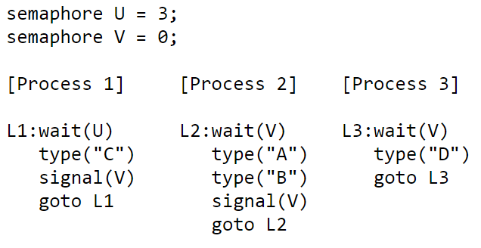

A. Random Number

B. 1

C. 2

D. 3

**🟊🟊🟊🟊🟊 Exercise 4 (Plickers):** How many D's are printed when this set of processes runs? (1 Minute)



A. Random Number

B. 1

C. 2

D. 3

**🟊 Exercise 5 (Plickers):** Given the above three concurrent processes,what is the smallest number of A's that might be printed when this set of processes runs? (30 Seconds)

A. 0

B. 1

C. 2

D. 3

**🟊🟊 Exercise 6 (Plickers):** Is CABABDDCABCABD a possible output sequence when this set of processes runs? Why? (1 Minute)

A. Possible

B. Impossible

C. the sequence always occurs

D. It depends on operating systems

**🟊 Exercise 7 (Plickers):** Two processes share a common variable X. X is set to 5 before either process begins execution. Statements within a process are executed sequentially. What are different values of X are possible after both processes finish executing? (2 Minutes)

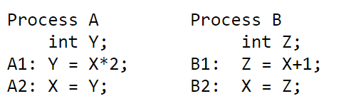

A. 6, 10, 11

B. 6, 10, 11, 12, 14

C. 6, 10, 12

D. 6, 10, 11, 12